Recieving Meteor M-N2 Images in Realtime with the QPSK Plugin on RTL-SDR Dongles

Before it was only possible to recieve Weather images sent from the Russian Meteor M-N2 Satellite in quite a complicated way.
Using the Baseband or IF recorder Plugin and Audacity to convert the recorded Wave-IQ to 130KHz and process this saved wave, for data extraction with LrptRX and finally get a image thru LrptDecoder.
As for searching continous ways to improve Meteor reception, Vasili (rtl-sdr.ru - Plugins) and Oleg (meteor.robonuka.ru - LrptDecoder) did have the great idea to develop a QPSK Plugin in order to recieve Meteor M-N2 images in realtime thru LrptDecoder.
This will save a lot of time and its not needed anymore to use other time consuming programs to convert the recorded Wave-iq.
Another advantage is QSPK Plugin gives a faster and longer signal lock with much weaker signal compared to IF-record resulting in longer images!

In short explained:

1. DDE Tracking client Plugin recieve data from Orbitron or other Tracking client.
2. If Satellite elevation > 0 (AOS) start decoder programm, set modulation and bandwidth, start some plugins (QPSK, IF or Baseband recorder) and send frequency correction.
3. If sattellite is gone (LOS) - recorders and other plugins are stopped, images are saved.
Orbitron (Satellite Tracking Program) are better/used for scheduler timings, the doppler triggers the start/stop by commands.

To Use Realtime image processing with Meteor, the following is needed for setup:

- RTL-SDR capable reciever or Airspy radio.

- 137Mhz Antenna Qfh, Turnstille or Cross dipoles.

- A Satellite Tracking program like Orbitron (http://www.stoff.pl) or WXTrack (http://www.satsignal.eu/software/wxtrack.htm).

- Up to date TLE files for Meteor M-N2 (http://www.celestrak.com/NORAD/elements/weather.txt).

- SDRSharp, QPSK Plugin, DDE Tracking client Plugin (Optional IF-recorder Plugin).

- LrptOnlineDecoder.

- Computer Clock must be synchronized!

Time Setup:

First its very important that the time on your PC is exactly synchronized.

The default Windows Time Service is not precise enough, David Taylor explains why overhere - http://www.satsignal.eu/ntp/setup.html#why

Either using his program http://www.satsignal.eu/ntp/setup.html or synchronize the time with a GPS mouse wih example this program: http://www.visualgps.net/NMEATime/default.htm or use any of your favorite NTP/GPS programs.
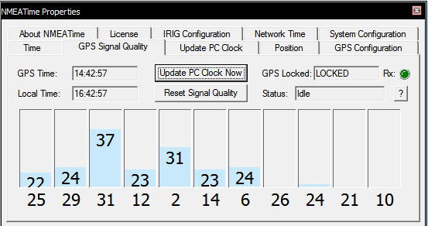

Plugins:

QPSK and DDDE Tracking client Plugin (Optional IFBaseband recorder Plugin).

Download the plugins add to the SDRSharp folder and copy the lines inside magic.txt to plugins.xml.

http://rtl-sdr.ru/uploads/download/qpskdemodulator.zip
http://rtl-sdr.ru/uploads/download/ddetracker.zip
http://rtl-sdr.ru/uploads/download/ifrecorder.zip
http://rtl-sdr.ru/uploads/download/basebandrecorder.zip

Orbitron:

Orbitron or WXtrack taking care of the doppler shift frequency correction for the carrier of QPSK Plugin.
And trigger the start of applications needed for the recieving session.

Note it's not gonna be used for correcting the main tuned frequency in SDRSharp the signal will be unlocked from the QPSK Plugin using that!

In this setup Orbitron is used as a Tracking Client:

Make sure Orbitron is installed (http://www.stoff.pl)

Open Folder location Orbitron\Config\setup.cfg in the driver section below add this line required to point out your working SDRSharp install/location:

[Drivers]

SDRSharp=<your path to SDRSharp folder>\SDRSharp\SDRSharpDriverDDE.exe

Save and start Orbitron, make sure you have a up2date TLE containing Meteor M2 Satellite.
Insert this url in Main/Click Tools Icon/TLE Updater:
(http://www.celestrak.com/NORAD/elements/weather.txt).

Select Meteor M2 in the right list with the checkbox.

Goto Main/Setup (the tool icon) Miscellaneous tab and set AOS notification to 0 (or any other elevation value when Meteor is receivable in your location).
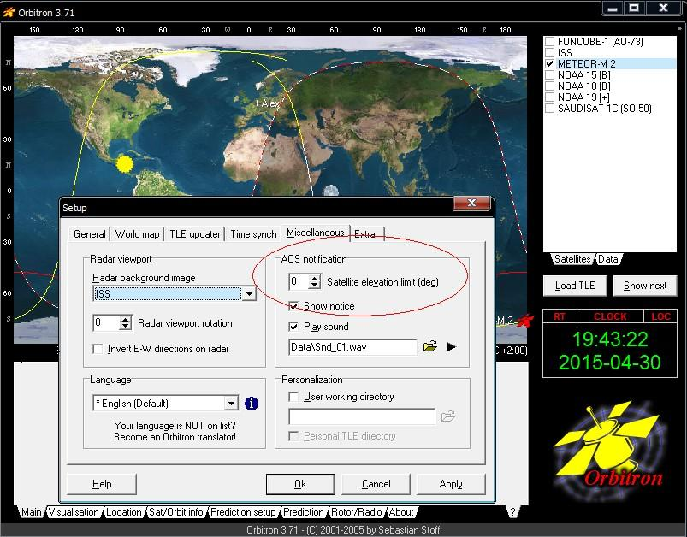
Then goto Extra tab last option AOS Notification: Make satellite active.
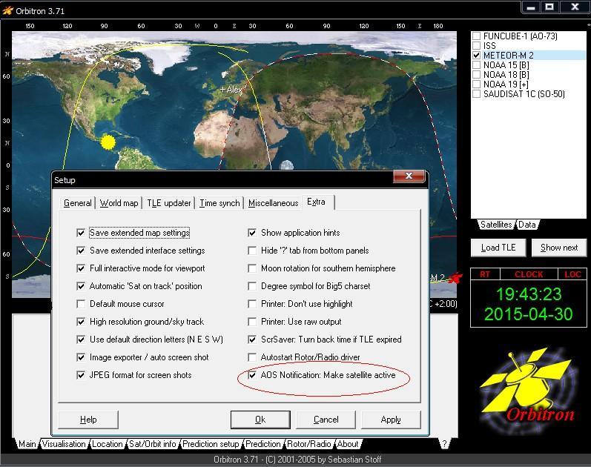
Fill in your location/GPS coordinates in the location tab.

Make sure your time zone is correct.
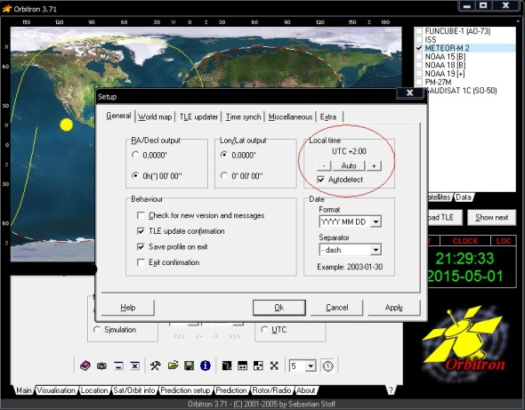

In the main tab you can select Orbitron’s update time interval, left from the clock icon set it to 1 second.
Goto tab Rotor/Radio, make sure in Dnlink/MHz: 137.100Mhz is filled in, Dnlink mode: FM-W.
Start SDRSharp.
Select SDRSharp in Orbitron from the Driver dropdown box and click the icon next to it to activate Doppler correction.
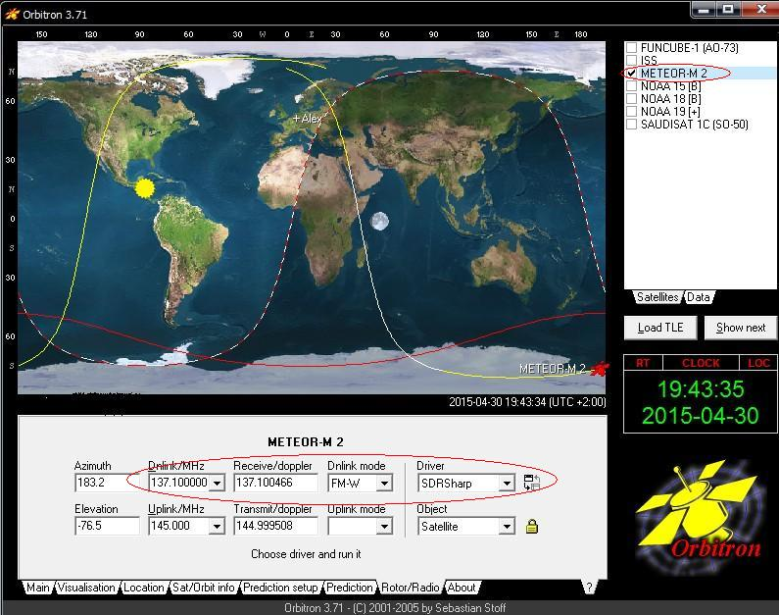
In DDE Tracking client Plugin you can see after a few seconds the sat name, frequency, Elevation is listed from Orbitron with Meteor's details indicating doppler is active.
Also in the windows tray bar a blue SDRSharpDriverDDE icon will appear.
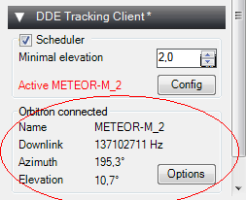
SDRSharp setup:

Main Frequency in SDRSharp must be set to 137.100Mhz Modulation WFM and preferred bandwidth 100-120Khz.
Tuner bandwidth to 1.4MSPS or any other value 2.048 MSPS Decimation /8 can be used with Vasili 3/1 modified driver for SDRSharp - http://rtl-sdr.ru/uploads/download/modrtlsdr.zip
DDE Tracking client Plugin setup:

In options button you can choose which Tracking program is going to be used, default is Orbitron.
A minimal elevation can be set like in Orbitron for example above 5 Degrees so the tracking client will be active and not on very low passes.

The config button are showing the available commands in order to start Auto record/scheduler this will be arranged by Orbitron triggered when the sat comes AOS.
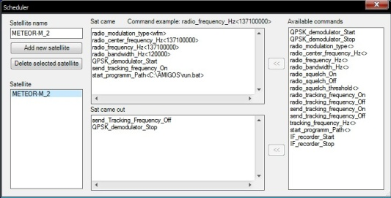
Default commands inside are allready setup for Meteor M-N2.

Sat Came window section command explanation:

radio_modulation_type<wfm> - Modulation Wide Band FM

radio_center_frequency_Hz<137100000> - set's the center frequency to 137.100MHz.

radio_frequency_Hz<137100000> - Tunes into 137.100MHz Meteors Lrpt Frequency

radio_bandwidth_Hz<120000> - Bandwidth used 120Khz recommend.

QPSK_demodulator_Start - QPSK Plugin is triggered to start from DDE Tracking Client by this command.

send_tracking_frequency_On - Starting Doppler frequency correction for QPSK Plugin carrier if the Satellite is acitive (If this is unwanted remove the command not recommend).

start_programm_Path<C:\AMIGOS\run.bat> - Path to Lrptdecoder for startup, decoding data reception in realtime (dont use a path with spaces example program files!).

Optional:

IF_recorder_Start or Baseband recorder to start a IF or baseband wave-IQ record.

Sat came out window section:

send_Tracking_Frequency_Off - Doppler correction for QPSK Plugin Carrier stops.

QPSK_demodulator_Stop - Stoping QPSK demodulation Plugin, LrptDecoder also quits saving received images.
IF_recorder_Stop or Baseband recorder to stop a IF or baseband wave-IQ record.

QPSK Plugin setup:

QPSK plugin send the received data in realtime to LrptDecoder via TCP Local Host connection (127.0.0.1) or can record and write a raw file called S-file which can be loaded directly in LrptOfflindecoder for slow computers.

Autosearch carrier inside the QPSK Plugin tunes to 137.100Mhz Meteor stream and lock on the signal if its strong enough.
When Sat Tracking is checked it uses Doppler correction for a faster signal lock.
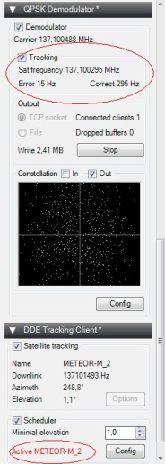
Note Tracking info will only displayed when the Satellite is active!

Also LrptDecoder will autostart when a signal is locked, Picture will build up line by line like the NOAA Satellite's in WXtoIMG.

If Meteors pass is over (LOS) DDE Tracking Client send 2 commands:

send_Tracking_Frequency_Off and QPSK_demodulator_Stop, Plugin will be inactive and LrptDecoder also quits saving recieved images.
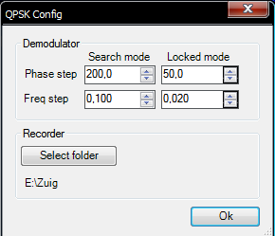
Some explainations from QPSK Config button:

phase step and freq step - pll coefficients.
pll frequency += frequency step * phase error
pll osc phase = pll frequency + phase step * phase error.

Recorder Select folder for the save location in file mode, a S-File will be saved which can be processed with LrptDecoder

LrptDecoder setup:
Download from http://meteor.robonuka.ru/for-experts/amigos/downloads/amigos-compatable-lrptofflinedicoder/
QPSK Plugin is required for this real-time processing.

Extract so it will be C:\AMIGOS\LRPToffLineDecoder.exe
Normal Operations will run on rgb=125.jpg (2 visible channels + 1 IR channel) containing all the information for the three separate channels.
Meteor once in a while has maintenance then the IR channel 5 is turned off for some days making Channel 1,2 and 3 active then this line must be inserted rgb=123.jpg (3 visible channels + no IR).

We do not now when this will happen, offcourse in real time processing it is not possible to change these RGB value’s.
That’s why a IF/Baseband-recording run along with realtime processing, to process it when the pass is over with the correct RGB ssetiings in the ini file of the decoder.
The IF/Baseband recording can be played back with SDRSharp and using a manual lock with the QPSK Plugin, or the old way convert it to 130Khz with Audacity and process it thru LrptRX.
Disadvantage of the last option is a quality loss of the image.
Changing the RGB setting and edit a custom image save path:
Open C:\AMIGOS\LRPToffLineDecoder.ini and you see the following:
This is for Localhost connection to QPSK plugin (no changes needed):
[IN]
source=tcp
host=localhost
port=2011
mode=72K

Change the line “rgb=122.jpg“ to ‘rgb=125.jpg” if 2 Visible channels and 1 IR channel is active and to “rgb=123” if IR is off.
And path=<your preferred path example E:\>

[OUT]
rgb=122.jpg
rgb_q=100
mono=jpg
logs=no
APID70=no
VCDU=no
path=C:\AMIGOS\Images
This is for the upcoming Amateur Meteor Images Global Observation System project in short called AMIGO more info at http://meteor.robonuka.ru/for-experts/amigos/ (no changes needed):
[GLOB]
path=C:\AMIGOS\SharedFolder

Save LRPToffLineDecoder.ini

Auto Start Lrptdecoder from DDE Tracking Client:
Make a new txt file, open it and paste inside:

START LRPToffLineDecoder.exe LRPToffLineDecoder.ini

Save it and rename to run.bat

Make sure in DDE Tracking client Plugin/scheduler the right path is given in start_programm_Path<C:\AMIGOS\run.bat> - Path to Lrptdecoder for startup, decoding data reception in realtime (dont use a path with spaces example program files!).

Now your setup is ready, when Meteor M-N2 comes over the horizon the running SDRSharp will autorecord and process the Weather images.
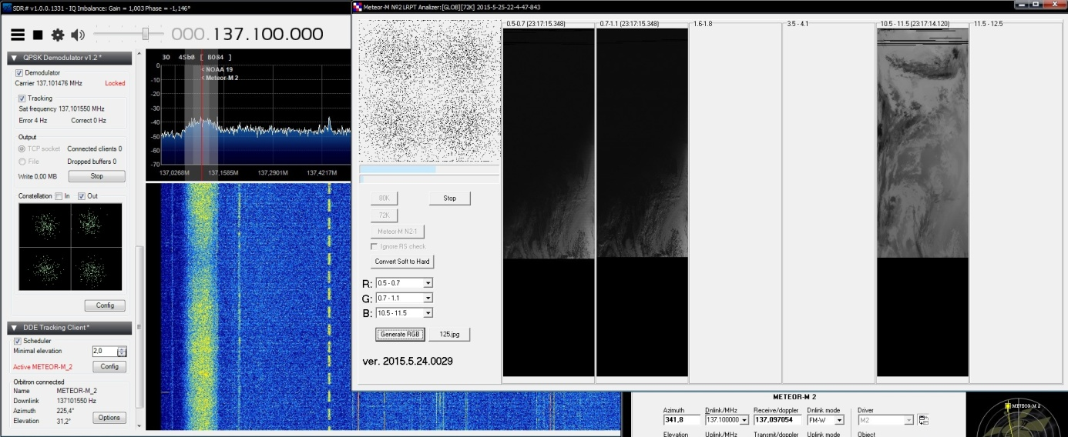

Image editing:
There are 2 excellent programs to edit Meteor's saved images, SmoothMeteor from Les Hamilton and LRPT Image Processor from David Taylor both are freeware.
They have option to rectify the image so the 'Fish-eye' effect is gone, Create False colors on RGB125 images, Flip Infrared Nighttime images and convert them with a negative effect so they look like NOAA IR Images.
And many other options.

Some extra explanations about Meteor images:
When you save a Meteor image as an RGB125 BMP image, the image actually contains all the information for the three separate channels.
If you wish to store your Meteor images for the future, this is the best way.
The new version of SmoothMeteor recognizes the 125.BMP part of the filename, and opens up the Palette menu.
Here you find options to add palettes to the images.
But you can also combine the channels in different ways: the RGB122 that is often used in LRPTofflineDecoder, but also the RGB125 (using the inverted channel 5), which is the same as the common color composites made from NOAA HRPT channels 1+2+4.
There are also options to save each of the individual grayscale channels.
http://myweb.tiscali.co.uk/wxsatellite/meteor3m.htm
So change in LRPToffLineDecoder.ini :

[OUT]
rgb=125.jpg

SmoothMeteor - http://myweb.tiscali.co.uk/wxsatellite/meteor3m.htm
LRPT Image Processor - http://www.satsignal.eu/software/LRPT-processor.html

Few things to consider:
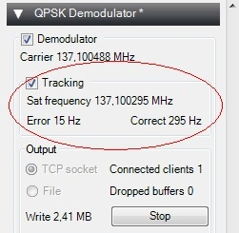
- If errors > 100 in lock mode there is either no correct local time synchronize or good PPM from the dongle.
Computer Clock time and PPM of the dongle must be synchronized for doppler correction to lower the error rate thus giving a faster signal lock!

For increase signal lock speed and to reduce the number of white lines:

1. To reduce gain of the tuner.
2. Try to change QPSK Config button - Freq step/Search mode from 0.100 to 1.
Prefered and default settings are:
Phase step/Search mode: 200,0 Locked mode: 50,0 (to shorten any black lines/stripes) .
Freq step/Search mode 0,100 and Locked mode: 0,020.
3. Adjust PPM value of the Dongle.
4. Computer Clock time must be synchronized
4. Move the receive frequency with the center of the screen to the left margin, 136.975 MHz (VDL2/Acars) can cause a strong signal which result in interference.
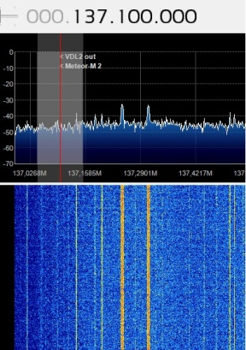
(This can be done by DDE Tracking client Plugin config button with command radio_center_frequency_Hz<137700000> - set's the center frequency to example 137.700MHz,
follow up command radio_frequency_Hz<137100000> - Tunes into 137.100MHz Meteors Lrpt Frequency leaving 137.100 on the left corner of the spectrum)

This whole session consumes a lot of cpu time especially on older pc's, you can try the file mode instead of realtime TCP if things are going really slow.

Alternative you can run LrptDecoder from another faster pc to decode the images in realtime with online decoder in your LAN network.
In OnlineDecoders LRPToffLineDecoder.ini you can fill in the host server (SDRsharp/QPSK) ip adress - host=<ip adres host server where SDRsharp and QPSK Plugin are running>

Or else the old method IF recorder, LrptRX and LrptOfflineDecoder..

In DDE Tracking client Plugin/scheduler there is a command for IF/Baseband recorder to start auto recording.

DDESchedule.xml with other satellite's Meteor M-N2, NOAA-15/18/19, ISS and Funcube can be downloaded over here: https://dl.dropboxusercontent.com/u/124465398/DDESchedule.rar insert and overwrite in SDRSharp folder for usage with DDE Tracking client Plugin.

NOAA Setup with DDE Sat Tracking Plugin:
It is also possible to have NOAA (WXtoIMG) and Meteor reception at the same time.
Take care of the orbits not crossing each other once in a while NOAA will be AOS at the same time when Meteor M-N2 comes over the horizon, make a predict in Orbitron and when it does occur uncheck NOAA so it will not interference with Meteor!

Download TLE from:

http://www.celestrak.com/NORAD/elements/noaa.txt

Note you can also use http://www.celestrak.com/NORAD/elements/weather.txt but NOAA’s naming is different in there:
In noaa.txt tle its: NOAA 15 [B] , NOAA 18 [B] , NOAA 19 [+] so in DDE scheduler it must be inserted with 2 underscores example NOAA_18_[B]
When using Weather.txt tle it have to be like this: NOAA 15 , NOAA 18 , NOAA 19 , so it must be example NOAA18
The above listed DDESchedule.xml does have the naming format of noaa.txt tle!
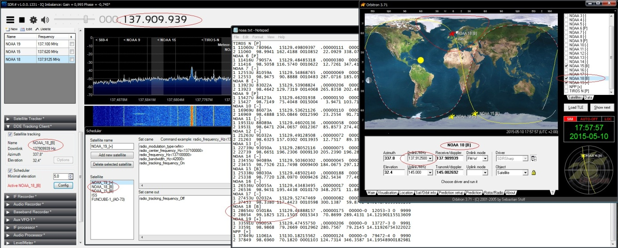
Many thanks to Vasili, Oleg and all testers (especially Jo and Peter) who did give great feedback on Yahoo-GEO Subscribers and Facebook APT-Group!
Tutorial version 2.0 27-05-2015 by Alex Happysat

