To: Carl Laufer, RTL-SDR blog
From: Mario Filippi, N2HUN
Date: October 5, 2015
Subject: Satellite Dish/L -Band Antenna for Inmarsat Reception
Dear Carl,
Inspired by the article in RTL-SDR.com entitled “Decoding Inmarsat STD-C EGC Messages” I decided to construct an L-band receiving antenna consisting of a WS International 90cm Ku band dish, a homebrew L-band LHCP helical antenna, and an in-line Eagle Aspen SA-2050+ 950 – 2200 MHz in-line amplifier.
First I built the L-band LHCP helical antenna mostly from parts in my junk box. The coil was built with solid copper wire, held in place with straws and mounted on a PCB. A can of Febreeze served as a coil wind form since it has the exact (58 mm) diameter needed. Antenna assembly instructions were found on the UHF Satcom link (http://www.uhf-satcom.com/lband).
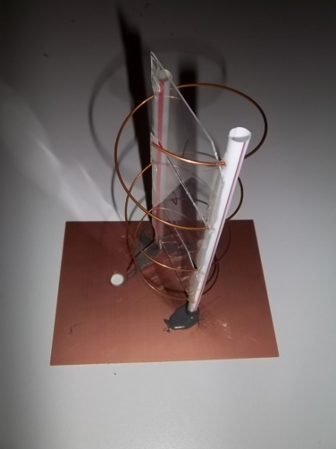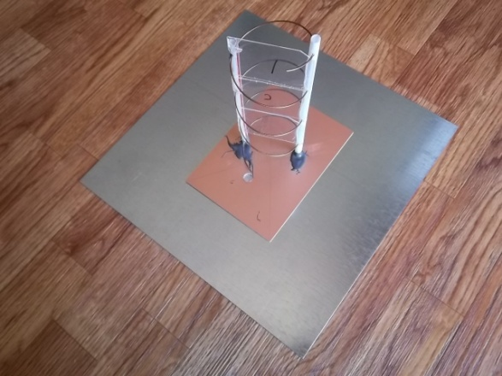
L band coil on PCB with straw PCB mounted and glued with JB Weld onto galvanized steel plate.
retainers. Thin pieces of plastic
were glued to the straws for
rigidity. Hole was drilled into PCB for
mounting an F bulkhead connector.

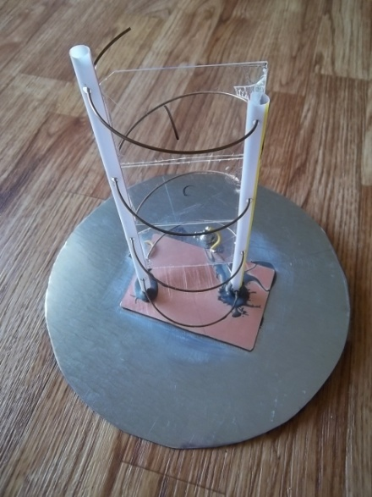
Antenna glued to galvanized steel plate, 200 mm diameter. Plate serves as counterpoise, purchased from Home Depot, originally one foot square, and cut with tin snips to proper diameter. Straws held in place with J-B Weld two part epoxy. Straws have holes drilled in them every 49 mm to maintain proper coil shape and distance.

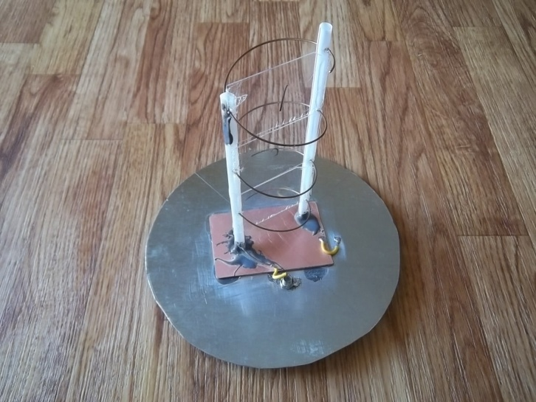
Next an F connector was soldered to the coil end, and the shield part grounded to the counterpoise and PCB.

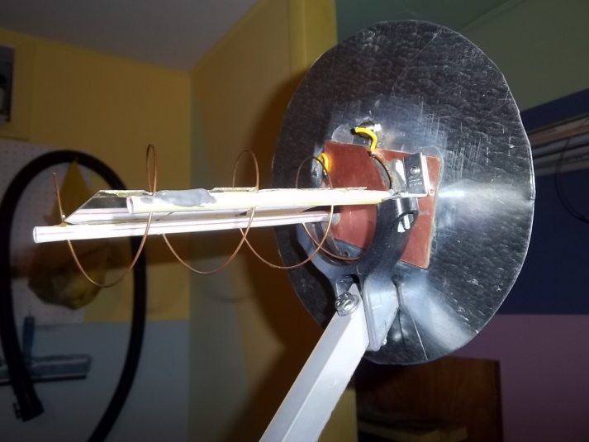
Next the antenna had to be custom mounted using a Ku band LNBF holder; this took some planning to ensure that the coil antenna was sturdily mounted. It was fastened with screws.

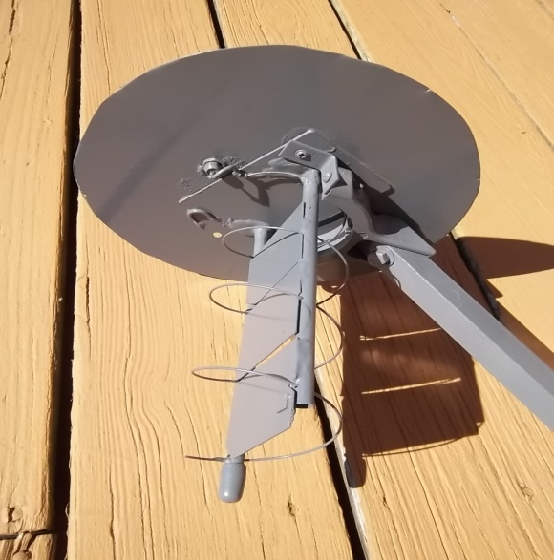
A coat of gray Rustoleum completed the job.

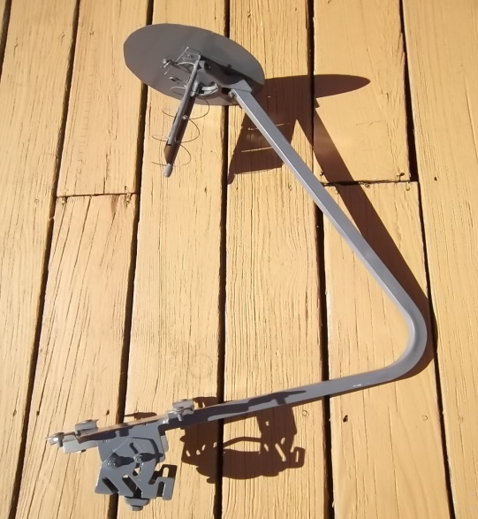
Here is what the L-band LHCP looked on the LNB arm prior to mounting on the dish.

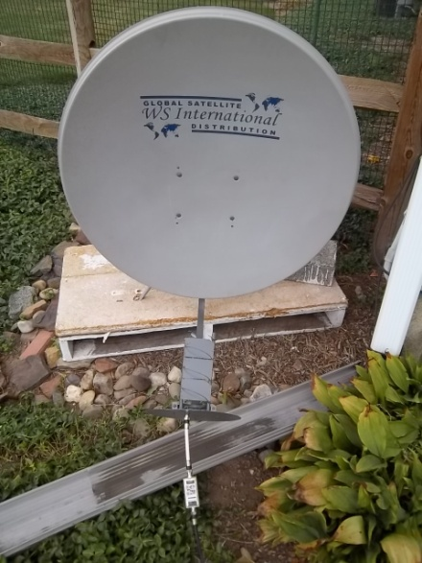
Next it was attached to the WS International 90cm Ku dish using a pallet mount weighted down with a concrete block. The pallet was adjusted to be plumb, as was the dish. An Eagle Aspen in-line amplifier was used instead of an expensive LNA to save money and in this case the Eagle Aspen worked perfectly. A run of about 30 feet of RG/6 coax was run into the shack.

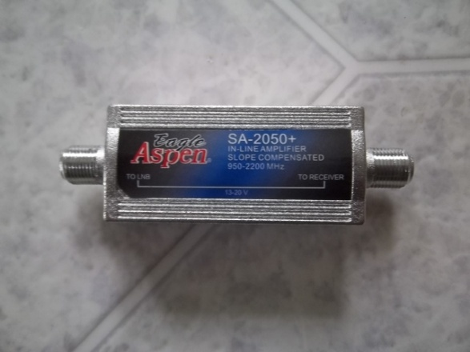
Close-up of the Eagle Aspen, bought on Ebay and definitely amplifies the satellite signal.

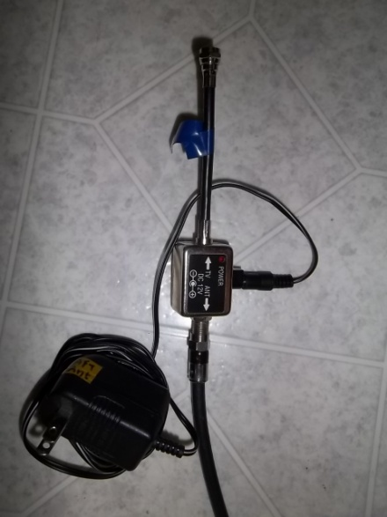
A 12V DC supply scavenged from an old in-line TV preamplifier was used to power the Eagle Aspen.

After consulting the tables in the UHF-Satcom website I decided to aim the dish at Inmarsat 3F2 located at 15.4W. Many years of experience in FTA (Free To Air) satellite made finding the satellite a snap. Here on the East Coast satellites at that low elevation are still able to be received. Inmarsat 3F2 is right next to the orbital slot of Telstar 12, an FTA satellite located at 15W, which is easily received on the East Coast.

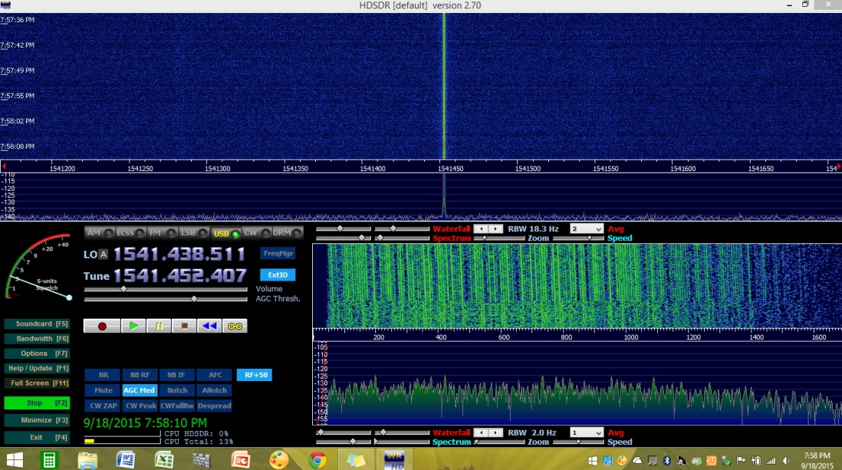
Next, using your RTL-SDR.com dongle, HDSDR, and a laptop, the Inmarsat control channel was seen on the spectrum.

Well, for now I am satisfied with good reception of Inmarsat 3F2, now all that is needed is a good decoding program! Thank you for printing that great article last August on Inmarsat reception. The method presented here was proven to work well for me. Feel free to use this information on the blog if you wish. Again, thanks and 73’s.

Sincerely,
Mario Filippi, N2HUN

