Hello guys,

I have been trying to get a software running to decode the hrit/xrit images from the w GOES 16 in Ubuntu.
Have done several attemps here but whith any luck. SO stopped looking and trying….
Since I have found interesting software that actually works under windows 7,8,8.1 and with a cheap sdr-rtl dongle , I decided to share it on the rtl-sdr website.
My call is on7ndr (Belgium) and the name is nico … qrz.com just for info.

Let start….
Lets find the url. In your favourite search engine….
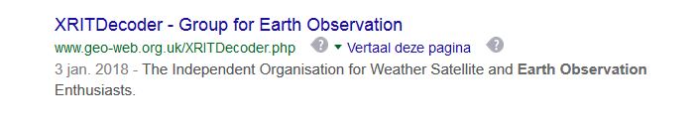
Read the full web page to get the the necessary info about the decoding process and the GOES 16 installation procedure.
Download first the PDF file “this page can be downloaded as .pdf Here
Scroll down the webpage then and click on the blue Microsoft links (1,2,) to get the exact visual studio Microsoft c++ 2010 that you need to install plus the Microsoft .net framework 4 .0
Please download also Microsoft visual C++ 2015 redistributable update 3 RC and install it.
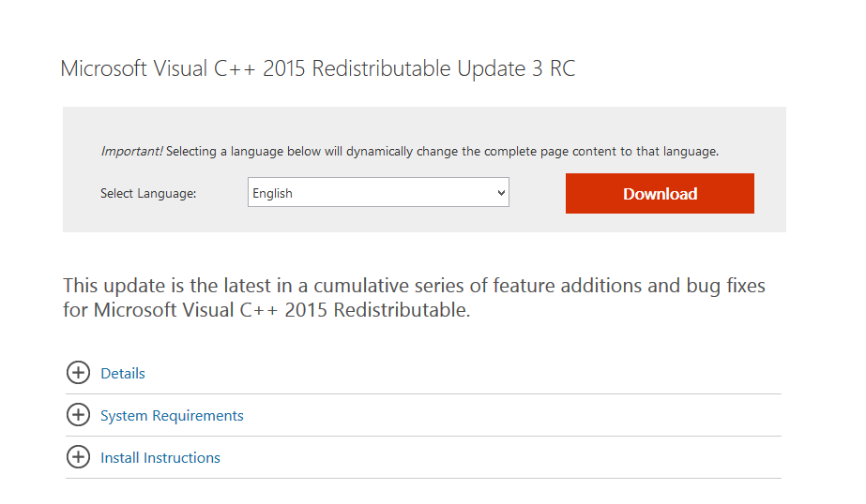
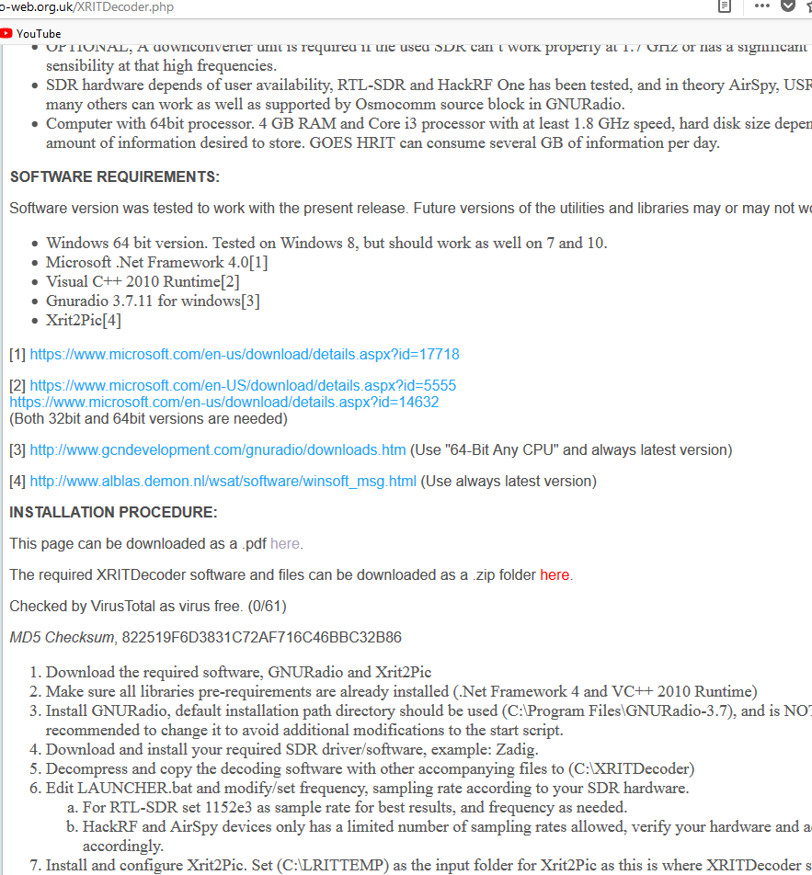
Then go to gnu-radio gcn development page and download please the correct gnu-radio for your 64 bit machine…. Windows….
After testing and installing xritdecoder , it seems a good way to choose this version , because otherwise you could get errors finding no vc140.ddl in your computer and other errors (0000077845) etc .so please take the one with the arrow in the jpeg
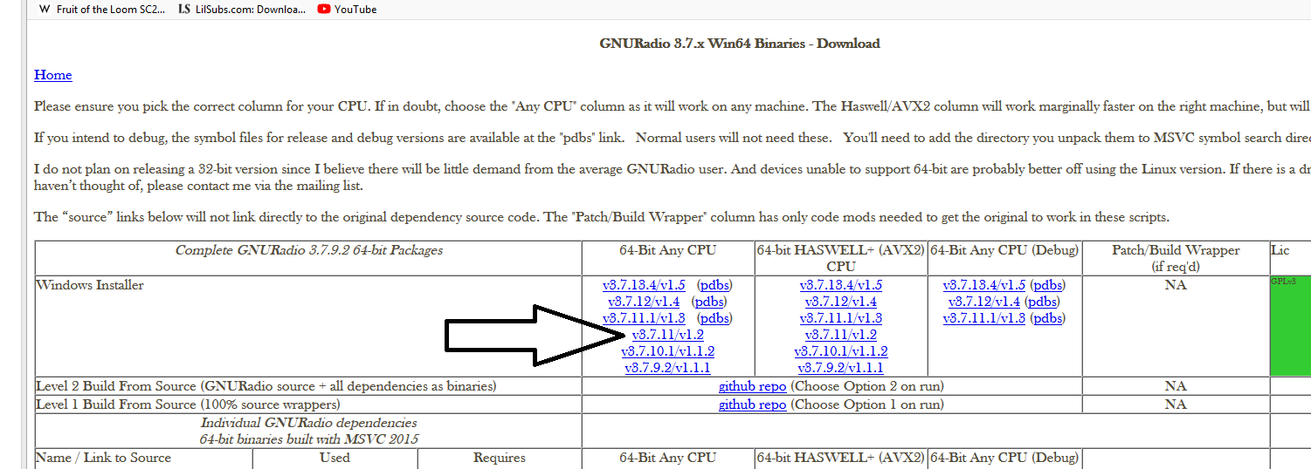
After installing gnuradio 3.7.11v1.2 without the pdbs please, we are ready to setup xritdecoder….
Download the “ zip” file XRITDecoder on the same webpage , unzip it with winrar or other 7zip machine
Then first determine what is your sdr-rtl dongle , is it a airspy , redpittaya, or just like me a simple rtl2832 or rtl2838 rt820t ezcap dongle.
For rtl-sdr dongle on rtl2832 or rtl2838 /rt820t base modify please first the “launcher.bat” file with wordpad , by going on the laucher.bat and right click mouse”edit” , edit it with wordpad , after editing simple save above in the window by “save” and close it
See the modified working rtl-sdr condition… batch file
After unzipping it has the location C:\XRITDecoder\XRITDecoder as you can see… keep this in mind for for modifying your batch file….
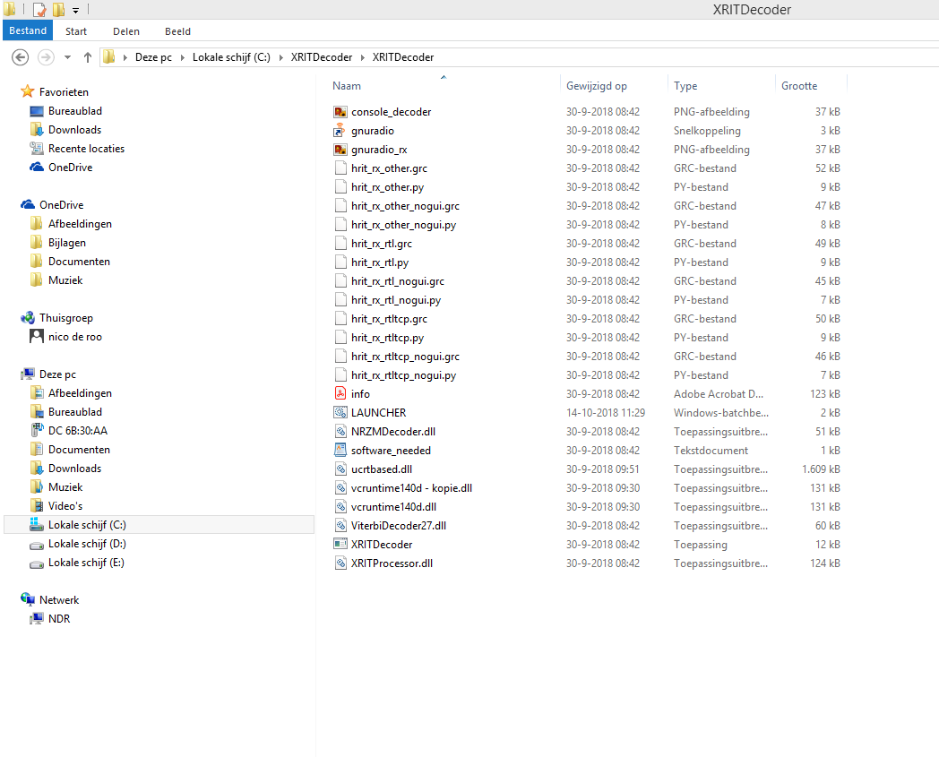

Now pick launcher.bat and edit it , by right clicking and choose then “” edit…””
For rtl2832 rtl-sdr simple type/modify the line into “ start /B gnuradio.lnk C:\XRITDecoder\ XRITDecoder\hrit_rx_rtl.py --1694100000 --samp-rate=1152e3 --gainrf=48.0 --symb-rate=927000 “
“Remember to ” rem” the original hrit_rx_other.py as you can see in the picture , so remove start and rem it (stop )

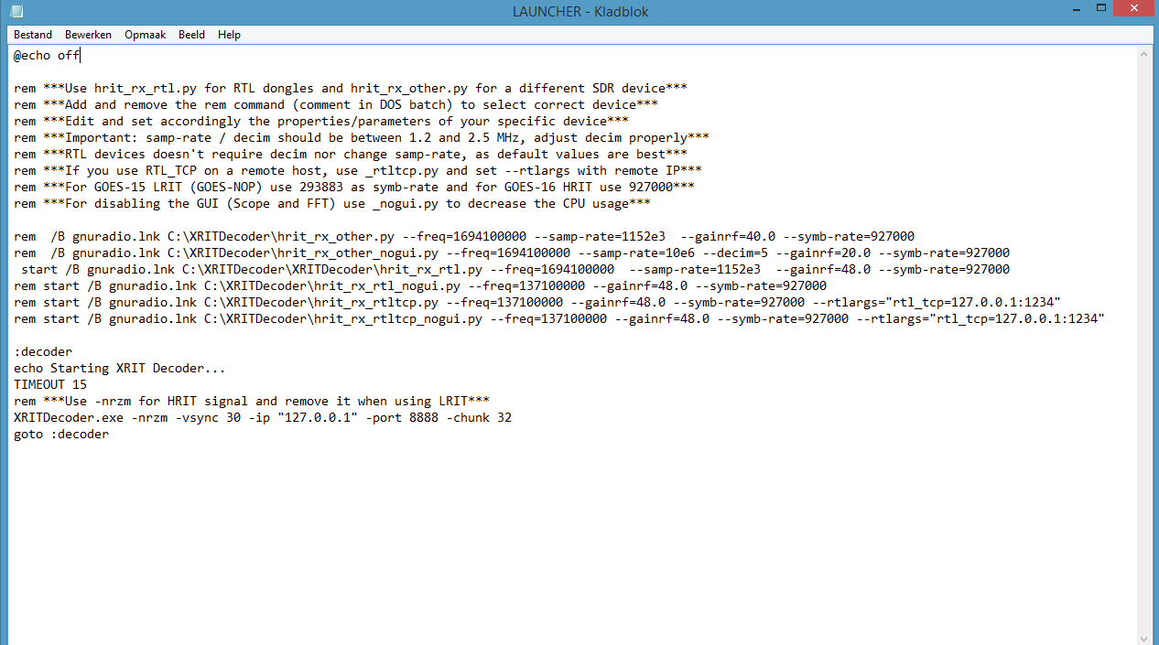
Look also a rtl –sdr dongle may have also no decim in the line , like some other dongles mayby need…
If you have a other dongle please use the hrit_other.py one by starting that up, and only 1 line may have the “start “ command , keep that also in mind…. 1 line
Now push the launcher.bat , if everything is ok gnuradio finds the hrit pyhon file and windows console and xritdecoder gets the data via tcp from gnuradio..
Hope it works , nico radioamateur ON7NDR;

MANY THANKS GO TO CM2ESP TO RELEASE THIS WINDOWS VERSION
YOU MUST ALSO INSTALL XRIT2PIC AND CONFIGURE THE PATH WHERE THE PICS ARE IN LRITTEMP
FOR INSTALLING XRIT2PIC DOWNLOAD THE 3 FOLDERS AND GO THRU THE SETUP ? INSTALL EVERYTHING EXACTLY IN THE SAME FOLDER ANYWHERE YOU WANT ? SO THE SAME LOCATION.

I ALWAYS WHEN THE SETUP’S ARE RUNNING CHOOSE C:\xrit2pic as default directory 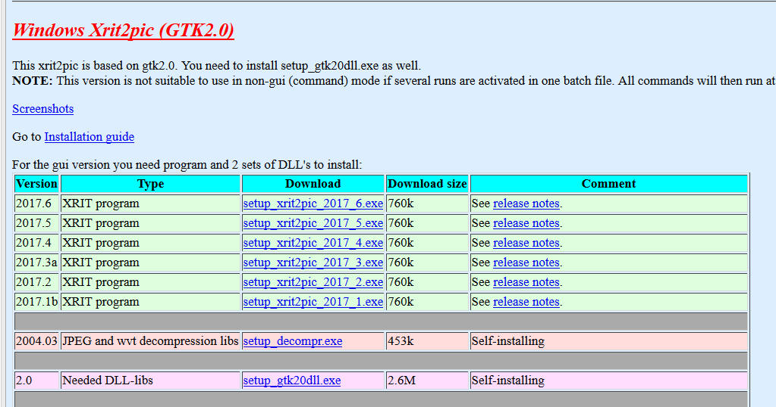
Download setup gtk.dll.exe
Download setup.decompress.exe
Download setup xrit2pic.2017.exe
Run the setup one by one and choose C:\xrit2pic everytime again as default directory
Startup xrit2pic by icon ; and go to preferences “record”
Choose for source directory “ LRITTEMP” by choosing c: and search for it …..up and down.
After that you could get full disk earth image normal.
Since I have no antenna ready , I can not yet give you a picture I have received , only the screen running the decoding goes16 and the plot and constellation in gnuradio
So keep testing other radioamateurs if it works….

